Smart Home Energy Monitoring System



Author(s)

Farhan Tariq UET-16F-BSc-EE-APCOMS-21

Asim Saddique UET-16F-BSc-EE-APCOMS-48

Huzefa Ali UET-16F-BSc-EE-APCOMS-72

Supervisor

Kiran Khurshid

Assistant Professor

DEPARTMENT OF ELECTRICAL ENGINEERING

ARMY PUBLIC COLLEGE of MANGAEMENT AND SCIENCES

Affiliated with

UNIVERSITY OF ENGINEERING AND TECHNOLOGY

TAXILA

August 2020

Smart Home Energy Monitoring System

Author

Farhan Tariq

UET-16F-BSc-EE-APCOMS-21

A thesis submitted in partial fulfillment of the requirements for the degree of

B.Sc. Electrical Engineering

Thesis Supervisor:

Kiran Khurshid

Assistant Professor Department of Electrical Engineering

External Examiner Signature:

Thesis Supervisor Signature:

DEPARTMENT OF ELECTRICAL ENGINEERING

ARMY PUBLIC COLLEGE of MANGAEMENT AND SCIENCES

Affiliated with

UNIVERSITY OF ENGINEERING AND TECHNOLOGY

TAXILA

August 2020

# UNdertaking

I certify that research work titled “*Smart Home Energy Monitoring System*” is my own work. The work has not been presented elsewhere for assessment. Where material has been used from other sources it has been properly acknowledged / referred.

Signature of Student

Farhan Tariq

UET-16F-BSc-EE-APCOMS-21

|  |
| --- |
|  |
|  |

Signature of Student

Asim Saddique

UET-16F-BSc-EE-APCOMS-48

Signature of Student

Huzefa Ali

UET-16F-BSc-EE-APCOMS-72

Abstract

Energy is a concerned matter across the globe. As excessive energy consumption can be harmful for environment and can cost next generation with no to very few energy resources, so we need to be careful while consuming energy. This can be achieved by monitoring and being aware of how much energy is being utilized on daily or monthly basis. So our focus is to monitor energy being consumed by our appliances which we normally use in our daily lives. The system uses wireless (Bluetooth) communication and displays the information on an LCD screen as well as on the mobile application.

**Keywords:** STM32, Current Sensing, Appliance Control, Smart Home, Android App, Energy Management

# Acknowledgements

*First and foremost, praise is to the Almighty Allah, who is the Almighty, the Merciful. We would like to extend our utmost gratitude to our supervisors Assistant Professor Kiran Khurshid, for her time and assistance. We are gratefully indebted for their valuable guidance in this project. Finally, we would like to express our thankfulness to our friends, teachers and parents for their never ending support and motivation throughout the process of working on our final year project.*

# Table of Contents

Abstract ………...ii

Acknowledgement iii

List of Figures vi

List of Tables vii

Abbreviations viii

Chapter I: Introduction 1

1.1 Overview 1

1.2 Statement Problem 1

1.3 Objectives 2

1.4 Background 3

Chapter II: Literature Review……………………………………... 4

2.1 Literature review 4

2.2 Project description 5

Chapter III: Methodology……………………………………... 6

3.1 Components Detail 6

3.1.1 STM32 Blue Pill 6

3.1.2 IR Sensor 7

3.1.3 DHT11 Sensor

3.1.4 Relay

3.1.5 Fan/DC motor

3.1.6 Bulb/Lamp

3.1.7 LCD 16x4

3.1.8 ACS712 Current Sensor

3.2 Block Diagram

3.3 Smart HEMS Functionality

3.4 Circuit Diagram / Working:

3.5 Android Application

3.5.1 Bluetooth Connection

3.5.2 Home Screen

3.5.3 Light Monitoring

3.5.4 Fan Monitoring

3.5.5 DHT11 Monitoring

3.5.6 Read From File

3.5.7 Notification screen

3.6 Methodology

3.6.1 Analysis

3.6.1 Modern Tools Usage

3.7 Code

Chapter IV: Results and Analysis ……………………………………...

4.1 Results

4.1.1 Simulation on Proteus

4.1.2 Mobile Application Results

4.2 Analysis

Chapter V: Conclusion ……………………………………...

# List of figures

*Number Page*

Fig 3.1.1 Stm32 Blue Pill (STM32F103C8T6) Figure 6

Fig 3.1.2 IR Sensor Figure 7

Fig 3.1.3 DHT11 Figure 8

Fig 3.1.4 Relay Figure 8

Fig 3.1.5 DC motor Figure. 9

Fig 3.1.6 Lamp/Bulb Figure. 9

Fig 3.1.7 LCD 16x4 Figure. 10

Fig 3.1.8 ACS712 Current Sensor Figure. 11

Fig 3.2 Block Diagram. 12

Fig 3.3 Smart HEMS Functionality Figure. 14

Fig 3.4 Circuit Diagram Figure. 15

Fig 3.5.1 Bluetooth Connection Figure. 16

Fig 3.5.2 Home Screen Figure. 17

Fig 3.5.3 Light Monitoring Figure. 18

Fig 3.5.4 Fan Monitoring Figure. 19

Fig 3.5.5 DHT11 Monitoring Figure. 20

Fig 3.5.6 Read From File Figure. 21

Fig 3.5.7 Notification Figure. 22

Fig 4.1 When simulation is not yet started Figure. 35

Fig 4.2 When Proteus simulation is running Figure. 36

Fig 4.3 Live sensor reading Screen Figure.

Fig 4.4 Fan monitoring Screen Figure.

Fig 4.5 Light monitoring Screen Figure.

Fig 4.6 Ecosystem/Environmental impact Figure.

Fig 4.7 Safety First Figure.

Fig 4.8 Health & Safety Figure.

Fig 4.9 Health & Safety Figure.

# List of tables

*Number Page*

Table 1.5.1 Structure of Project

Table 3.9.1 Components of FYP

Table 1.3 Price of the Components

# Chapter 1

**Introduction**

* 1. **Overview:**

Energy is a concerned matter across the globe. The energy production’s surroundings impacts are reduced vastly by energy management activities. Hence, the need of monitoring energy consumption has been preferred as a vital process which results in immediate reduction of energy being utilized.

As excessive energy consumption can be harmful for environment and can cost next generation with no to very few energy resources, hence we need to be careful while consuming energy. So this project can be important in a sense that, it will be able to monitor energy consumption and will be able to show results of energy utilization through mobile app.

* 1. **Statement Of Problem:**

Advancement within the area of present enumeration opens a large amount of potential for the look of energy economical systems in smart homes energy monitoring. Present enumeration and integration an outsized variety of sensors, actuators, and enumeration devices into our daily surroundings have incredible ability to play vital part in way of living. Energy potency is changing into progressively necessary in trade additionally as within household community. In any case, because of the complexness and variety of enumeration devices, integration vitality potency into present enumeration remains in its early stage. Addition of every new device into the surroundings needs an excellent deal of labor. Once decided that explicit device to join, the smart home developer should verify the way to tack it together and interface it. Next step involve device must be connected and physically desegregated it into the surroundings. Importance of energy potency in our household is much more than connecting devices to the surroundings. The smart home surroundings makes wireless usage of sensing element network programme to integrate varied heterogeneous gadgets. These gadgets ought to work with alternative gadgets severally to supply smart services for customers within the smart home.

The current utility framework only gives feedback towards the month’s end bill, measured in kilowatt hours (kWh). With the help of this monitoring device, the consumer can better manage its appliances to lower the cost per month and track their energy usage on more daily/monthly basis.

* 1. **Objectives:**
* Sensor interfacing
* Current sensing
* Appliance control
* Mobile app
* Real-time current and energy consumption monitoring
* Real-time plots and graphs
  1. **Background:**

There are 2 ways for energy monitoring in household from smart grid and household network [4, 6, 7]. A smart-grid observes and measures the usage of electricity remotely employing a smart meter and communication network [5]. It gives timespan or occurrence to timeframe information on the utilization of vitality to firms or administration firms. The greater part of the frameworks happens to keen metering for family unit in brilliant network are exclusively that represent considerable authority in movement the general amount of vitality utilization or power at a home and correspondence establishment for data bunch activity. So as to analyze the vitality utilization of each family unit gadget, higher smart administrations may be given like following vitality utilization, applied arithmetic investigation, and rule-based design. Inside the home system space, the information of vitality look at from each family gadgets are gathered at abuse locator systems. Numerous frameworks for perception and prevailing force utilization are anticipated [2, 3]. Their principle commitment has been to style and actualize vitality measure and the board frameworks. In this methodology, every vitality the executive’s administration is encased. The anticipated framework contemplates on sending a remote locator arrange and executing vitality the board/predominant assistance as encapsulation administrations in brilliant home.

* 1. **Structure:**

Structure of our thesis is such that it is self-explanatory. But will be explained for convince. Structure of thesis is discussed briefly in the given table below:

**Table 1.5.1: Structure of Project**

|  |  |  |
| --- | --- | --- |
| **Chapter I** | Introduction | This chapter consists of overview, Problem statement followed by objectives and at last background of FYP. |
| **Chapter II** | Literature Review | This chapter consists of literature review and project description. |
| **Chapter III** | Methodology | This chapter describes components being used; block diagrams and method and techniques of our FYP. |
| **Chapter IV** | Results and Analysis | This chapter mainly discusses about the results of our project and different topics of analysis. |
| **Chapter V** | Conclusion | This chapter at the end concludes our findings. |

# Chapter 2

**LITERATURE REVIEW**

* 1. **Previous Work:**

Smart Home Monitoring System has being gaining popularity worldwide at an enormous

rate. With the increasing expense of home energy use, particularly electrical power, it has been essential to know the amount of electrical power utilized by different appliances so wasteful employments of power can be disposed of. Since home spending budget relies on the measure of energy utilized during various periods, for example, time of day, day of the week, or period of the year, it is favorable to realize which timeframes were cause for the maximums and minimum of energy use, and which specific appliance contributed most intensely during those specific periods to the aggregate sum of energy utilized.[1] While it is conceivable to acquire a month to month, every day or week after week all out for total home energy use by perusing the outside energy meter, such a training is off- kilter and unwieldy. Besides, the main data that can be acquired from the utility meter is the complete energy utilization of the whole living arrangement. Clearly it can't be resolved from the utility meter which specific appliance contribute the most to the aggregate sum of energy utilization inside some random time period.[2]

Smart HEMS is a great concept but it does not provide us with current sensing feature. We monitor our appliance on daily basis as well on monthly basis. Appliance utilizing more power can be easily detected .Smart power control feature can easily control the appliance. It is manually opera table by mobile application.

This main function of this invention is to monitor and track power energy on daily as well

as total energy consumption. The appliance is connected to android application which tracks and monitors the consumption as well as the cost in real time. The android application also triggers an alarm if one of the appliances is consuming more power. The app also serves the ability to control if an appliance exceeds the power consumption.

* 1. **Project Description:**

In this project, our main focus is to monitor energy usage and to let know the user about it. This project also allows and automates the light and fan with the help of sensors which give data to STM32 Blue Pill to control accordingly. While it is user friendly, it is also environment friendly too.

# Chapter 3

**METHODOLOGY**

* 1. **Components Detail:**
     1. **Stm32 Blue Pill (STM32F103C8T6):**

The ARM Cortex M3 STM32F103C8 Microcontroller is used in the Blue pill board. There is meaning behind Microcontroller’s name STM32F103C8T6. STM32 has its own memory and static RAM along with debugging option for your STM32 system.

Features of STM32 are as below:

* Contains the main Microcontroller the STM32F103C8T6 in a Quad Flat Package.
* Two LEDs _ User LED and Power LED.
* 8 MHz Crystal _ Frequency of Main Clock of Microcontroller.
* 32.768 KHz Oscillator _ Frequency of Real Time Clock.
* SWD or Serial Wire Debug Interface _ for debugging and programming.
* 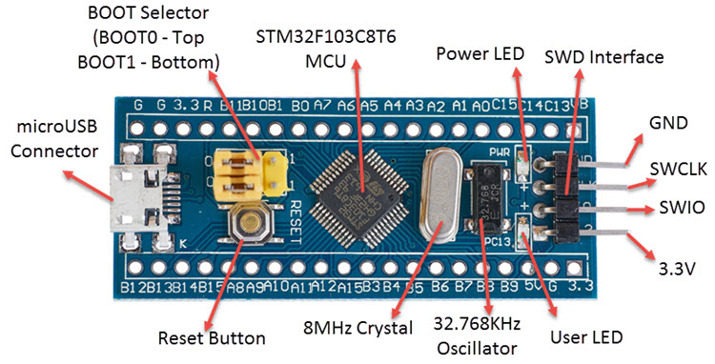3.3V Regulator _ for conversion of 5V to 3.3V to power the Microcontroller.

**Figure 3.1.1**

* + 1. **IR Sensors:**

An infrared sensor analyzes infrared light transmitting from objects in its area of view. They are usually used to identify and sense infrared based motion. PIR sensors are generally used for security purposes and are programmed through different microcontrollers for light switching applications. PIR sensor in our project is used to detect people entering room, so our programmed STM32 can turn ON or OFF the lamp.

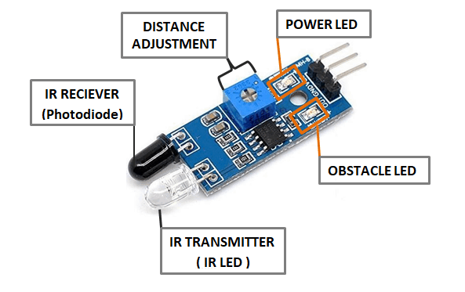

**Figure 3.1.2**

* + 1. **DHT11 Sensor:**

DHT11 is usually used to measure temperature and humidity within an area. Normally it measure temperature using built-in thermistor and for humidity a capacitive humidity sensor to attain data from atmospheric air, and gives out data on the data pin of sensor in form of digital data. It is easy to use, but timing is the key when it comes to grabbing the data to be used. The only concerning drawback of DHT11 is delay as you get new data after each 2 seconds of interval. This sensor will be also used in our switching circuit. This sensor will help us to detect humidity so fan can be adjusted accordingly.

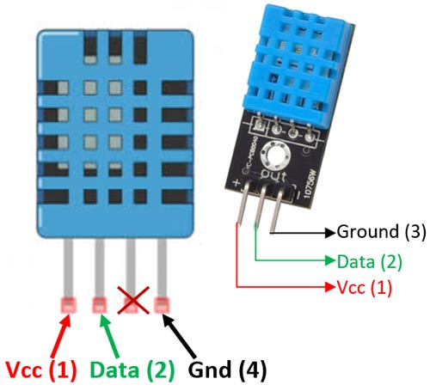

**Figure 3.1.3**

* + 1. **Relay (5 V):**

A relay is a switch which is operated electrically. Signal is sent to the relay at one point and this signal controls whether the circuit will be closed or open in electronic sense. So relay acts as a switch which electromechanically controls circuits and electronic devices. Relay has normally 5 pins. Two coil pins, one for normally open, one for normally closed and the last one is movable arm pin.

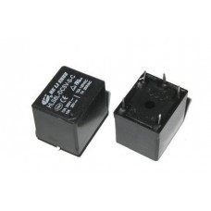

**Figure 3.1.4**

* + 1. **Fan/DC Motor:**

A 12v DC motor will be used as a Fan that will turn ON when high temperature is detected which will close the relay circuit causing fan to turn ON, and will be turned OFF when temperature falls below a specific temperature.

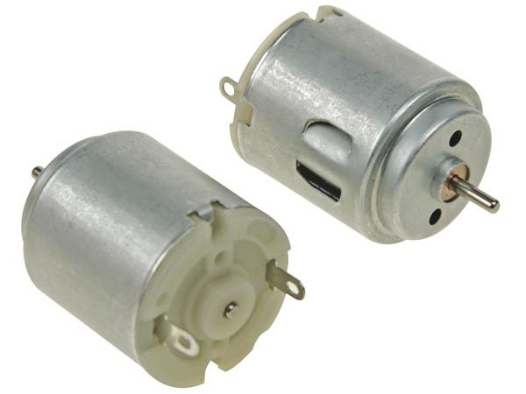

**Figure 3.1.5**

* + 1. **Bulb/Lamp:**

An AC 220V, 5-12Watt Bulb will be used as a lamp in our project. Whenever someone enters in the room while the light intensity will be less than a specified value, the bulb will be turned ON and whenever the person leaves the room, bulb will be turned OFF.

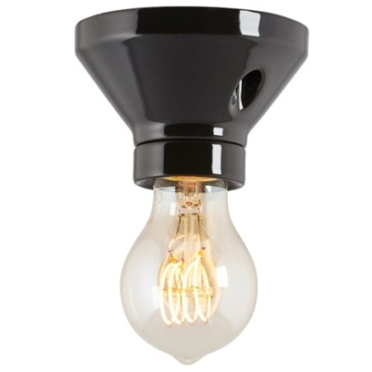

**Figure 3.1.6**

* + 1. **LCD (16x4):**

A 16x4 LCD display is fairly common used module and usually interfaced with different devices and microcontrollers. In simple words, a 16x4 LCD means it has 16 columns and 4 rows, which also means that it can display 16 characters at a time on each 4 rows at the same time. Each character of LCD has 5x7 pixel matrix display. This intelligent 16x4 LCD is capable to display 224 different variety of characters and symbols. LCD will display message whether someone is inside room or not, to the user.

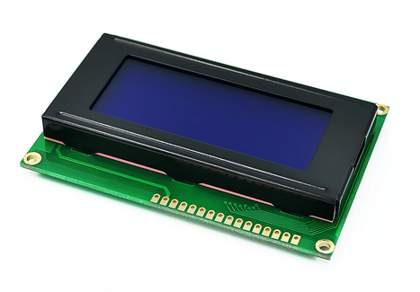

**Figure 3.1.6**

**Figure 3.1.7**

* + 1. **ACS712:**

ACS712 is a Current Sensor that is used to detect, calculate and analyze the amount of current being applied to the conductor of the current sensor without interfering with the performance of the system. ACS712 Current Sensor is an integrated linear sensor IC, which operates on the phenomenon of Hall-effect.

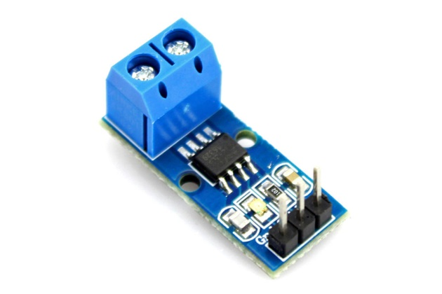

**Figure 3.1.8**

* + 1. **Table of Components:**

**Tab. 3.1.1: List of Components**

|  |  |  |
| --- | --- | --- |
| **Sr #** | **Component** | **Quantity** |
| 1 | STM32 Blue Pill | 1 |
| 2 | IR Sensor Module | 2 |
| 3 | DHT11 | 1 |
| 4 | Relays 5V | 2 |
| 5 | AC/DC Motor | 1 |
| 6 | Bulb | 1 |
| 7 | ACS-712 | 2 |
| 8 | LCD (16x4) | 1 |
| 9 | Vero board | 1 |
| 10 | Connecting Wires | 3 meters |
| 12 | Screw terminal blocks – 2 pins | 6 |
| 13 | Female headers – 4 pins | 6 |

* 1. **Block Diagram:**

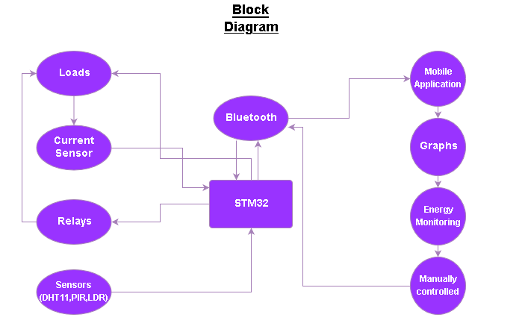

**Figure 3.2.1**

* Basically we will use current/voltage sensors to sensed Current/Voltage of loads and that data is sent to the microcontroller.
* The microcontroller we used in our project is STM32F103C8T6 also known asSTM32-Blue Pill**.** It’s a powerful and a modern development board that can be programmed on Arduino IDE.
* On the other hand, Temperature, Light and Presence sensors will also be working in parallel to sense the environment about the change. These sensors are connected directly to the STM32.
* To automatically turn the appliances ON or OFF, relays will be used that will connect/disconnect the loads from the supply based on the calculations of the microcontroller.
* A Bluetooth module is used in our project to communicate wirelessly with our designed Mobile Application.
* Our Mobile Application will receive data for real-time monitoring of the environment, to plot real-time graphs about temperature, humidity and the power being consumed by the loads. Also the user can control home appliances by the mobile application by turning them ON/OFF.
  1. **Smart HEMS Functionality:**

Smart HEMS provides an informative summary relating to the graphic sorts of energy usage. Few advanced functions usually comprise information, automation, observation etc. The machine-driven operations here oﬀer the client’s choice so as to work out the preferences with the home instruments and native generation of functionalities.

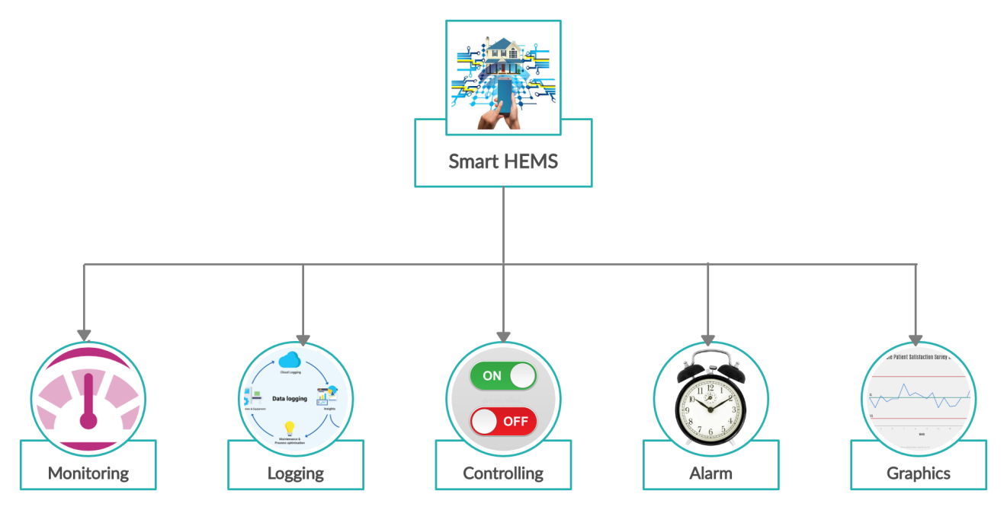

**Figure 3.3.1**

Smart HEMS consist of ﬁve major functioning modules as shown in Fig 3.1.1:

* **Monitoring—** It is process in which data being monitored is more feasible for the user to access, which makes easy for the user to conserve energy as they please. It provides the user to visualize services on their mobile phone screens for each of their smart devices.
* **Logging—** Logging is a method of assembling and conserving the knowledge and data regarding how much of electricity is being consumed by every. This practicality includes inspecting the insistence of the user of electric appliances feedback for period of time, which gives out the consumed power/energy costs.
* **Control—** Direct management additionally manage exercised on in addition device and also the system, while the device controls indicates the consumers accessibility to controlling devices, also observation of the utilization patterns of smart devices using varied completely different systems and devices, e.g. Laptops/Desktop computers or smartphones.
* **Alarm**— Alarms and notifications are generated additionally displayed on the mobile application whenever the smart device’s energy consumption is close to the limit defined by the user.
* **Graphics**— Real-time graphic overview on the mobile application of the appliances’ current and energy consumption along with the Temperature and Humidity graphs are also displayed, so that the user have the insights about the smart home environment in his own palm
  1. **Circuit Diagram / Working:**

**Switching Part** of our project consists of STM32, 2-PIR sensors, 1-DHT11, Bluetooth module HC-06, 1-LCD 16x4, 2- Relays (5v), 1 Fan, 1 Lamp, and a Voltage Source (220v AC). DHT11 will read temperature and humidity and the IR Sensors will detect presence/movement data, and will send it to STM32. The collected data will be processed and will be shown on the LCD. This information will also be wirelessly transmitted to the mobile app through the Bluetooth module HC-06. Based on the processed data the Fan and Lamp will be turned ON/OFF automatically.

**Current Sensing** **Part** of our project consists of 2-ACS712, 2-Relays (5v). Current sensors will be connected in series between the load and the voltage source to directly measure the flowing AC current through the load. The measured output value of the current sensors will be sent to the STM32 that will convert the output of ACS712 that will be in voltages to its respective current value. This current after processing will be used to calculate the power consumed by each load and also to analyze the usage of appliances.

* When there is nobody in the room, fan is OFF whatever the room temperature is, light is also OFF because nobody is in the room.
* Whenever someone enters into the room, counter value is increased and light is turned ON. Fan will only turn ON if the room temperature is greater than 25, if less than 25, fan will remain OFF.
* Lamp and Fan can be turned ON/OFF manually by the consumer using android app.
* Lamp will be turned OFF when the consumed energy is greater than 750 Wh.

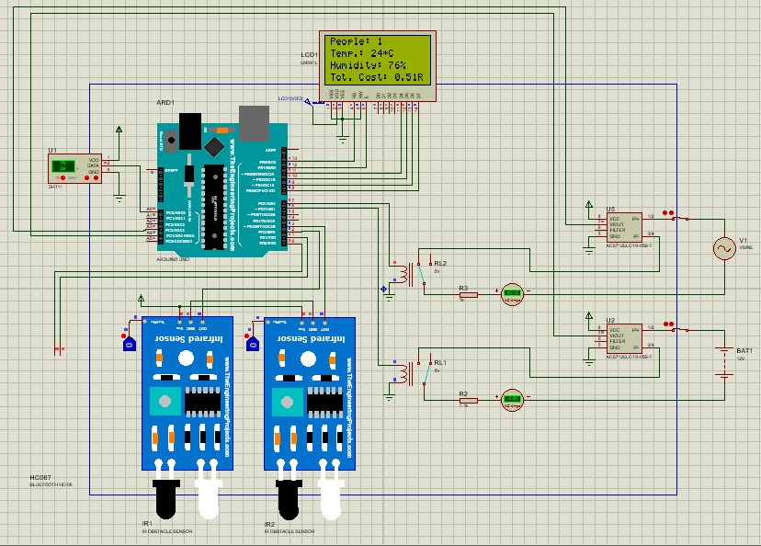

**Figure 3.4.1**

* 1. **Android Application:**

Our Android application consists of 5 different screens named below:

* 1. Bluetooth Connection Screen
  2. Home Screen with live sensors data
  3. Light Monitoring Screen
  4. Fan Monitoring Screen
  5. DHT11 Monitoring Screen
     1. **Bluetooth Connection:**
  + Connect/Disconnect Buttons
  + Status of connection.
  + Connected Device BT Address and Name
  + Exit App Button

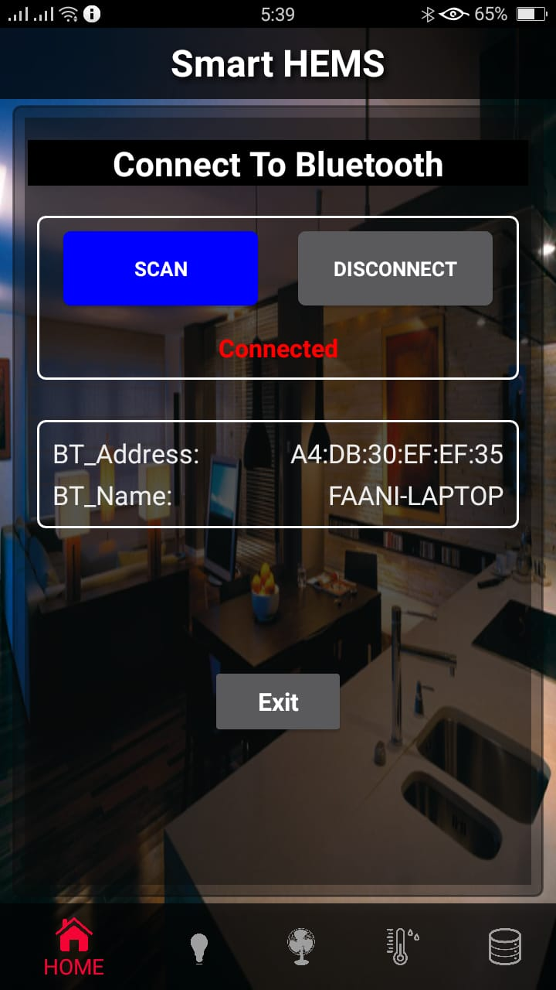

**Figure 3.5.1**

* + 1. **Home Screen:**
  + Temperature, Humidity Reading
  + Current and Power being consumed by Lamp in Watt Hour (Wh)
  + Current and Power being consumed by Fan in Watt Hour (Wh)
  + People present in the Room Counter
  + 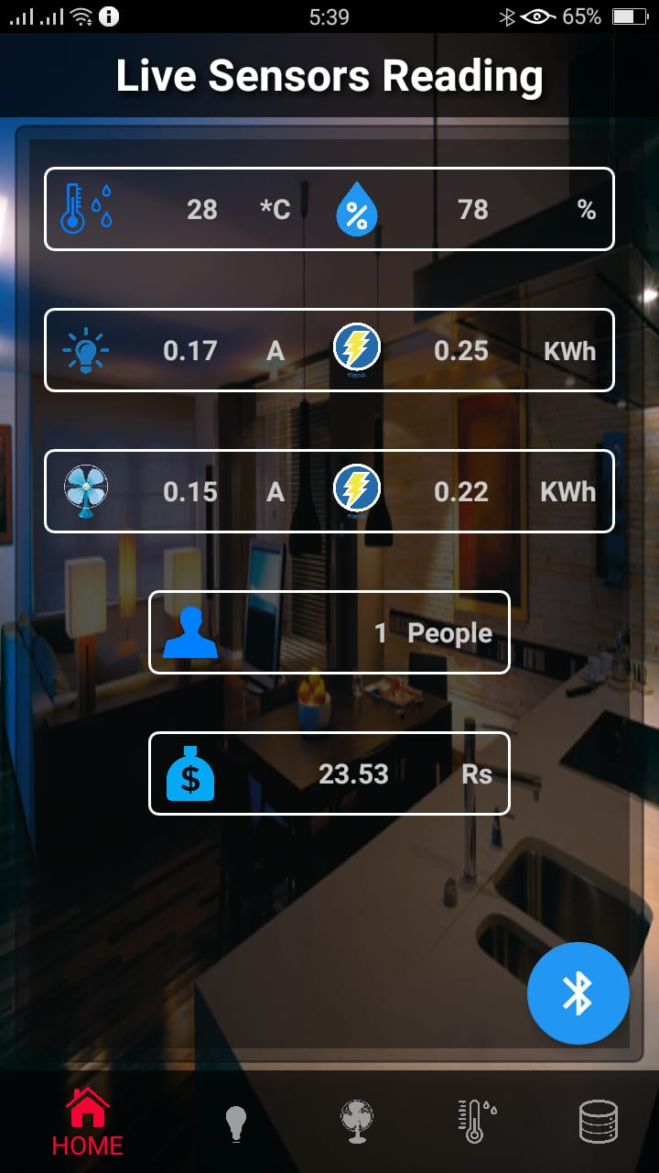Total Cost/Bill

**Figure 3.5.2**

* + 1. **Light Monitoring:**
  + Current being consumed by Lamp in Watt Hour (Wh)
  + Energy being consumed by Lamp in Watt Hour (Wh)
  + People present in the Room Counter
  + Manual turning ON/OFF the light bulb
  + Real-Time Current and Energy Graph

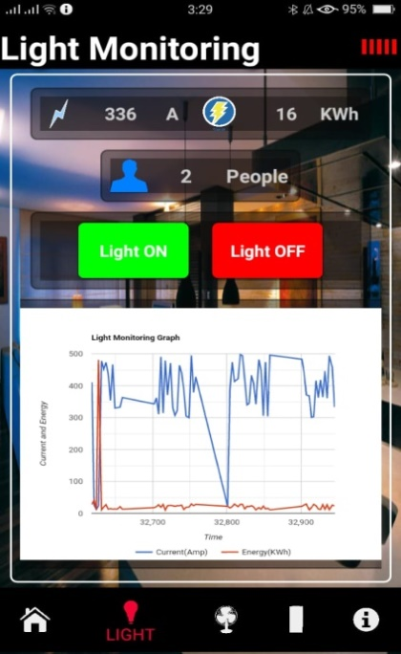

**Figure 3.5.3**

* + 1. **Fan Monitoring:**
* Current being consumed by Fan in Watt Hour (Wh)
  + Energy being consumed by Fan in Watt Hour (Wh)
  + Manual turning ON/OFF the Fan
  + Real-Time Current and Energy Graph

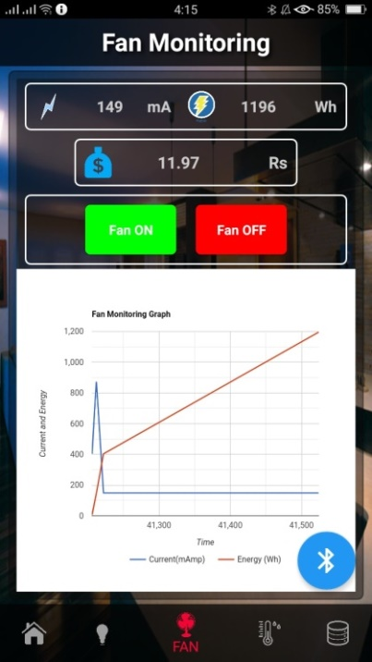

**Figure 3.5.4**

* + 1. **DHT11 Monitoring:**
  + Temperature Reading
  + Humidity Reading
  + Real-Time Temperature and Humidity Graph

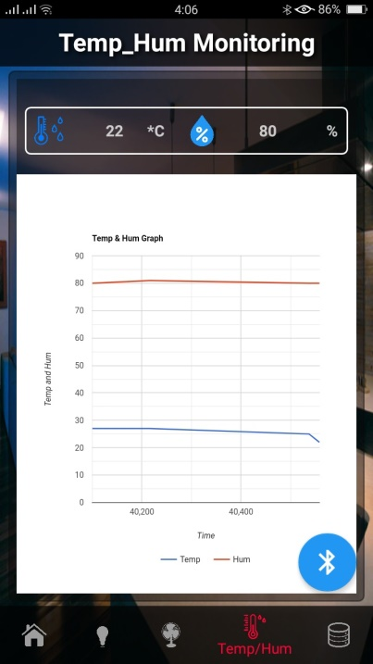

**Figure 3.5.5**

* + 1. **Read From File:**
  + Read temperature and humidity data from DHT11 File
  + Read Current and Energy (Watt Hour) of Lamp from Lamp File
* Read Current and Energy (Watt Hour) of Fan from Fan File

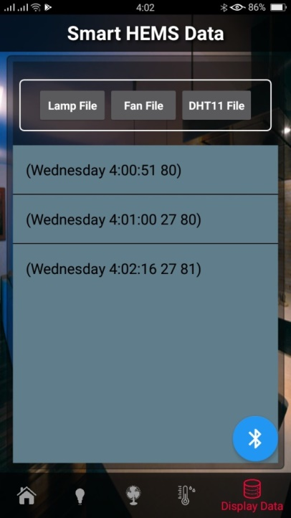

**Figure 3.5.6**

* + 1. **Notifications:**
  + If the consumed energy by lamp or fan is greater than 500 Wh, the consumer will receive a notification.
  + If the total cost is greater than 1000 Rs, the user will receive a notification.

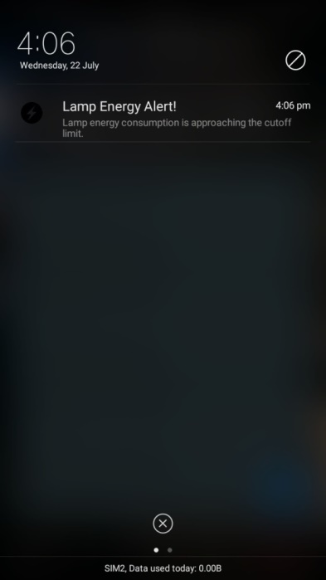

**Figure 3.5.7**

* 1. **Methodology:**
     1. **Analysis:**
  + Smart HEMS is a great concept but it does not provide us with current sensing feature.
  + We will bill our appliances which will provide us with monthly usage data.
  + Appliances utilizing more power than necessary can be detected.
  + Smart power control feature introduced by using Arduino / STM32 Blue Pill.
  + Manually operate-able using mobile application.
    1. **Modern Tools Usage:**

The software that we are using to design the software part and the interfacing of the hardware part are:

* + Proteus Professional (to design all the required circuits used in our Smart HEMS).
  + Arduino IDE (to compile the program and remove errors from the code and burn code to the STM32 Blue Pill).
* MIT App Inventor (for designing of our android app).
  1. **Code:**

/* Written By: Farhan Tariq Janjua

B.Sc Electrical Engineering

www.APCOMS.edu.pk

-------------------------------------------------------------------

-Set Lamp Energy Limit in Controlling Lamp Section.

-Set Fan Energy Limit in Controlling Fan Section.

*/

#include "DHT.h"

#include "LiquidCrystal.h"

LiquidCrystal lcd(PB9, PB8, PB7, PB6, PB5, PB4);

#define DHTPIN PB3

#define DHTTYPE DHT11

DHT dht(DHTPIN, DHTTYPE);

#define RELAYLight PB12

#define RELAYFan PB13

#define in PB14

#define out PB15

int counter=0;

int islightOn=0;

int isFanOn=0;

char btVal=NULL;

int t = 0;

int h = 0;

/* ========Current Circuit variables definition======== */

#define currentPin1 PA15

#define currentPin2 PA12

int mVperAmp = 185;

float PF = 0.80;

float energyTariff = 10.0;

unsigned long last_time1 =0;

unsigned long current_time1 =0;

float VoltageLamp = 0;

float VRMSLamp = 0;

float LampAmp = 0;

float LampPow = 0;

float LampKWh =0;

float LampBill = 0;

int Lamp_Wh = 0;

int Lamp_mAmp = 0;

float Total_Cost = 0;

unsigned long last_time2 =0;

unsigned long current_time2 =0;

float VoltageFan = 0;

float VRMSFan = 0;

float FanAmp = 0;

float FanPow = 0;

float FanKWh =0;

float FanBill = 0;

int Fan_Wh = 0;

int Fan_mAmp = 0;

void setup()

{

lcd.begin(16,4);

analogWrite(PA8,200);

Serial1.begin(9600);

dht.begin();

pinMode(DHTPIN, INPUT);

pinMode(in, INPUT);

pinMode(out, INPUT);

pinMode(currentPin1, INPUT);

pinMode(currentPin2, INPUT);

pinMode(RELAYLight, OUTPUT);

pinMode(RELAYFan, OUTPUT);

lcd.print("===Smart HEMS===");

delay(3000);

attachInterrupt(digitalPinToInterrupt(PA12),IN,RISING);

attachInterrupt(digitalPinToInterrupt(PA15),OUT,RISING);

attachInterrupt(digitalPinToInterrupt(PA10),BTI,RISING);

}

void loop()

{

/*=====Temp. and Humidity Sensing=====*/

t = dht.readTemperature();

h = dht.readHumidity();

if(Serial1.available()>0) {}

/*=====Bluetooth Receiving=====*/

BTI();

/*=====Presence Sensing=====*/

if(digitalRead(in))

{

IN();

delay(200);

}

if(digitalRead(out))

{

OUT();

delay(200);

}

if(counter>0)

{

if (islightOn == 0)

{

if (btVal == 'a' || (counter > 0 && btVal == NULL))

{

digitalWrite(RELAYLight, HIGH);

islightOn = 1;

}

}

if (islightOn == 1)

{

if(btVal == 'b' || (counter == 0 && btVal == NULL))

{

digitalWrite(RELAYLight, LOW);

islightOn = 0;

}

}

if (isFanOn == 0)

{

if (btVal == 'c' || (t >= 25 && btVal == NULL))

{

digitalWrite(RELAYFan, HIGH);

isFanOn = 1;

}

}

if (isFanOn == 1)

{

if (btVal == 'd' || (t < 25 && btVal == NULL))

{

digitalWrite(RELAYFan, LOW);

isFanOn = 0;

}

}

}

if(counter == 0)

{

digitalWrite(RELAYLight, LOW);

islightOn = 0;

digitalWrite(RELAYFan, LOW);

isFanOn = 0;

}

if(islightOn == 0 && isFanOn == 0)

{

Total_Cost = Total_Cost;

}

if(islightOn == 1)

{

calcLamp();

Total_Cost = Total_Cost + LampBill;

}

if(isFanOn == 1)

{

calcFan();

Total_Cost = Total_Cost + FanBill;

}

/* ========Bluetooth Data Transmit======== */

Serial1.print(t); // #01

Serial1.print("|");

Serial1.print(h); // #02

Serial1.print("|");

Serial1.print(counter); // #03

Serial1.print("|");

Serial1.print(Total_Cost); // #04

Serial1.print("|");

Serial1.print(Lamp_mAmp); // #05

Serial1.print("|");

Serial1.print(Lamp_Wh); // #06

Serial1.print("|");

Serial1.print(Fan_mAmp); // #07

Serial1.print("|");

Serial1.print(Fan_Wh); // #08

Serial1.print("|");

Serial1.print(LampBill); // #09

Serial1.print("|");

Serial1.print(FanBill); // #10

Serial1.print("|");

/* ========Counter/Temp/Hum Data Display======== */

Disp_All();

delay(2000);

Disp_Lamp();

delay(2000);

Disp_Fan();

delay(1500);

}

/* ========Bluetooth Interrupt======== */

void BTI()

{

btVal = Serial1.read();

}

/* ========IR Sensors Interrupts======== */

void IN()

{

counter++;

Disp_All();

}

void OUT()

{

if (counter > 0)

{

counter--;

Disp_All();

}

}

/* ========Current Sensors Subroutines======== */

float getVPP1(int pin)

{

float result;

int readValue;

int maxValue = 0;

int minValue = 4096;

uint32_t start_time = millis();

while((millis()-start_time) < 200) //sample for 200 milliSeconds

{

readValue = analogRead(pin);

if (readValue > maxValue)

{

maxValue = readValue;

}

if (readValue < minValue)

{

minValue = readValue;

}

}

result = ((maxValue - minValue) * 5.0)/4096.0;

return result;

}

/*=====Lamp Current Sensing=====*/

void calcLamp()

{

VoltageLamp = getVPP(currentPin1);

VRMSLamp = (VoltageLamp /2.0) *0.707;

LampAmp = (VRMSLamp * 1000) / mVperAmp;

Lamp_mAmp = LampAmp * 1000;

LampPow = (LampAmp * 220) * PF;

last_time1 = current_time1;

current_time1 = millis();

LampKWh = LampKWh + LampPow *(( current_time1 - last_time1) /3600000.0) ;

Lamp_Wh = LampKWh * 1000;

// LampBill = LampKWh * (energyTariff/1000);

LampBill = LampKWh * energyTariff;

}

/*=====Fan Current Sensing=====*/

void calcFan()

{

VoltageFan = getVPP(currentPin2);

VRMSFan = (VoltageFan/2.0) *0.707;

FanAmp = (VRMSFan * 1000) / mVperAmp;

Fan_mAmp = FanAmp * 1000;

FanPow = (FanAmp * 9) * PF;

last_time2 = current_time2;

current_time2 = millis();

FanKWh = FanKWh + FanPow *((current_time2 - last_time2) /3600000.0) ;

Fan_Wh = FanKWh * 1000;

// FanBill = FanKWh * (energyTariff/1000);

FanBill = FanKWh * energyTariff;

}

/* ========Display All Data Subroutines======== */

void Disp_All()

{

lcd.clear();

lcd.setCursor(0,0);

lcd.print("People: ");

lcd.print(counter);

lcd.setCursor(0,1);

lcd.print("Temp.: ");

lcd.print(t);

lcd.print("*C");

lcd.setCursor(-4,2);

lcd.print("Humidity: ");

lcd.print(h);

lcd.print("%");

lcd.setCursor(-4,3);

lcd.print("Tot. Cost: ");

lcd.print(Total_Cost);

lcd.print("Rs");

}

/* ========Display Sensor's Data Subroutines======== */

void Disp_Lamp()

{

lcd.clear();

lcd.setCursor(0,0);

lcd.print("People: ");

lcd.println(counter);

lcd.setCursor(0,1);

if (islightOn == 0)

{

lcd.print("Light: OFF ");

}

if (islightOn == 1)

{

lcd.print("Light: ON ");

}

lcd.setCursor(-4,2);

lcd.print(Lamp_mAmp);

lcd.print("mAmp");

lcd.setCursor(5,2);

lcd.print(LampPow);

lcd.print("W");

lcd.setCursor(-4,3);

lcd.print(Fan_Wh);

lcd.print("Wh");

lcd.setCursor(5,3);

lcd.print(LampBill);

lcd.print("Rs");

}

void Disp_Fan()

{

lcd.clear();

lcd.setCursor(0,0);

lcd.print("Temp.: ");

lcd.print(t);

lcd.println(" *C");

lcd.setCursor(0,1);

if (isFanOn == 0)

{

lcd.print("Fan: OFF ");

}

if (isFanOn == 1)

{

lcd.print("Fan: ON ");

}

lcd.setCursor(-4,2);

lcd.print(Fan_mAmp);

lcd.print("mAmp");

lcd.setCursor(5,2);

lcd.print(FanPow);

lcd.print("W");

lcd.setCursor(-4,3);

lcd.print(Fan_Wh);

lcd.print("Wh");

lcd.setCursor(5,3);

lcd.print(FanBill);

lcd.print("Rs");

}

# Chapter 04

**RESULTS AND ANALYSIS**

* 1. **Results:**
* We will show majority of our results on our mobile application.
* Other results shown will be on LCD (16x4) and through working of our loads operated by relays and DHT11 and IR Sensors.
* Results can also be in the form of simulation on Proteus or on any simulation software but mainly we will be working with Proteus.
  + 1. **Proteus Simulation:**

**When simulation is not yet started**

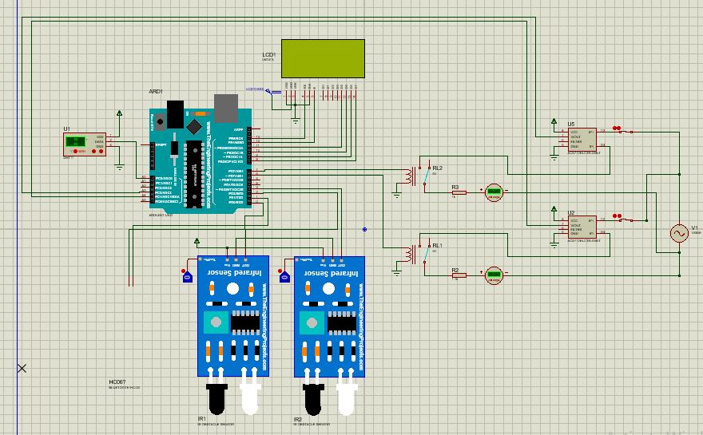

**Figure 4.1.1.1**

* In above figure, we can see/observe that simulation has not yet been started due to which no result is being shown on our LCD (16x4).

**When Proteus Simulation is Started**

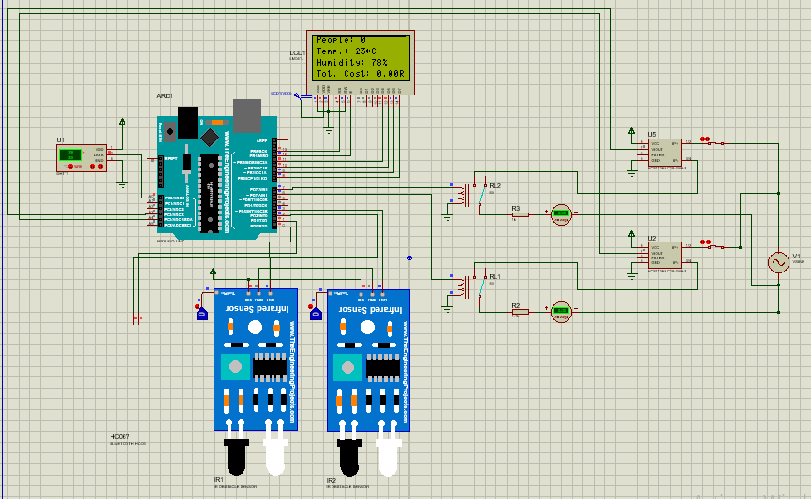

**Figure 4.1.1.2**

* As it can be seen in above given figure (4.1.1.2) that LCD is working properly and is displaying all the parameters needed for this project such as number of people, Temperature, Humidity and Total cost of utilization of energy.
* Each IR sensor has its own purpose and have a defined role such that one IR Sensor will be placed at entrance and one on exit gate to perform their respective tasks to detect people coming in and going out of a designated place or room.
  + 1. **Mobile Application Result (Graph):**

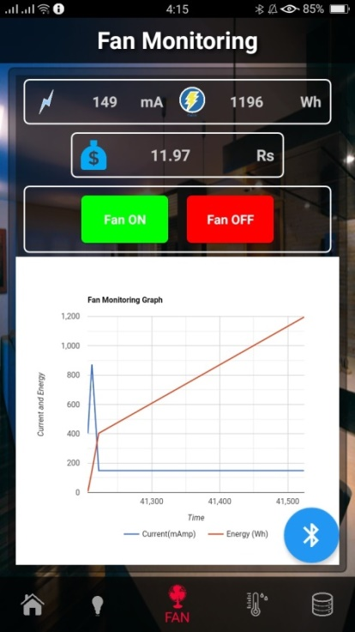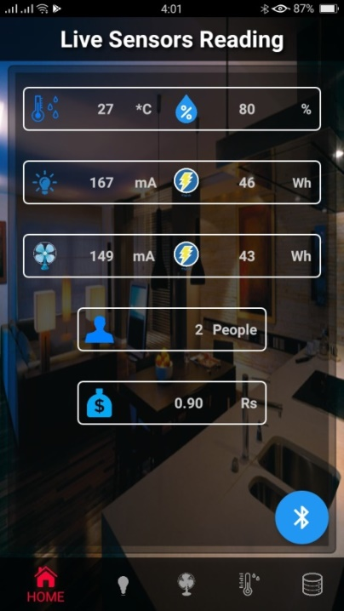

**Figure 4.1.2.1 Figure 4.1.2.2**

* As it can be seen in figure 4.1.2.1 that, all the readings of sensors are being displayed.
* And in figure 4.1.2.2 it can be seen that, graph is being plotted of time vs. current and energy for fan monitoring.
* Blue line displays current and red line is showing us power against time.

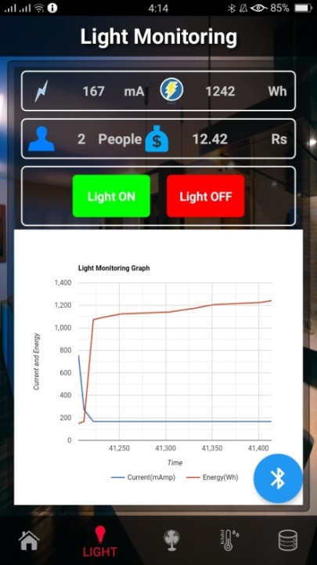

**Figure 4.1.2.3**

* In figure 4.1.2.3, current and energy are being plotted against time but this graph is for Light/Lamp monitoring.
* Blue line displays current and red line is showing us energy against time.
  1. **Cost:**
* Our project is cost effective and cheap, as it has very little expenses for a project this beneficial.

**Table 4.2.1**

|  |  |  |
| --- | --- | --- |
| **Sr #** | **Component** | **Price** |
| 1 | STM32 Blue Pill | 650 |
| 2 | IR Sensor Module | 300 |
| 3 | DHT11 | 170 |
| 4 | Relays 5V | 100 |
| 5 | AC/DC Motor | 100 |
| 6 | Bulb | 100 |
| 7 | ACS-712 | 600 |
| 8 | LCD (16x4) | 550 |
| 9 | Vero board | 80 |
| 10 | Connecting Wires | 30 |
| 11 | Screw terminal blocks – 2 pins | 60 |
| 12 | Female headers – 4 pins | 100 |
| 13 | TOTAL | **3000/-** |

* 1. **Environmental Impact:**
* This project will not harm environment in any way.
* This project will be environment friendly as we are designing project in which energy being consumed is being calculated constantly, which will helpful a lot for the consumer or user to observe and save energy.
* By saving energy we are also saving different resources of our surrounding such as water which runs turbines to produce electricity and wind energy can also be considered.
* In other words, we are contributing a little part to save this planet and its ecosystem.



**Figure 4.3.1**

* 1. **Manufacturability:**
* Manufacturing of this project is supposedly not that easy as it seems but is not impossible.
* The design of schematic is implemented Vero board and soldered through soldering wire.
* Implementing design on hardware also had other set of problems such as solder tip not working properly, troubleshooting of hardware and software.
  1. **Ethics:**
* Ethically it is not well advised to steal someone else’s work without right references and recognition of the source and the author well defined in your thesis.
* It is also unethical to have plagiarism of thesis to be more than allowed.
  1. **Health and Safety:**
* Health and safety is essential for any project. As electronics related projects, with High voltages put the user at risk so one needs to be very careful and needs to follow safety measures.
* 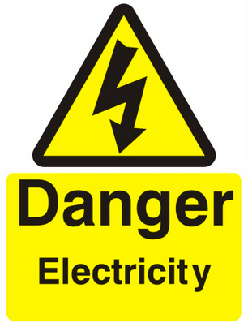 Few of the safety measures are put on gloves while handling/ working with High voltages.

**Figure 4.6.1**

* Secondly, the consumer or user needs to be mindful of high voltages being measured by current sensors.
* Also there is the risk of voltage being supplied to the Loads directly from the socket, which can be lethal for any person if he/she comes in contact with the main voltage line.
* So health and safety issues need to addressed and project also should be handled carefully.
* Projects and all of electrical appliances/ Loads should always be placed far apart from any wet area.



**Figure 4.6.2**

* 1. **Sustainability:**
* This project is sustainable as the connections are soldered quite firmly.
* And this project will be placed on a wooden slab to make it stable and to give it a presentable look.

# Chapter 05

**CONCLUSION**

Advancement within the domain of omnipresent computing unfolds a vast amount of potentialities for the organization of energy economical techniques in subsequent smart homes. Omnipresent quantifying and group action an oversized range of sensors and actuators plus the other computing devices into our daily life surroundings have subtle prospective to accord energy potency in individual’s lifestyle. Energy dominance is turning into progressively necessary in trade similarly as within the household sector. Even so, because of the complexness and variety of computing devices, group action energy potency into omnipresent computing remains in its early days. Affixing every new device into the atmosphere needs a good dispense of labor. Once determining that specific device to incorporate, the smart home developer should confirm a way to set it up and interface with it. After that the device should be linked and incorporated it into the atmosphere. Understanding energy potency in accommodations implies much more than linking devices to the atmosphere. The smart home atmosphere makes use of a wire-less detector network manifesto to incorporate various heterogeneous devices. These devices ought to join forces with alternative devices severally to produce canny facilities for users within the smart homes.

**REFERENCES**

1. RS Carr, JN Dalzell, JF Holmes, JM Hunt “Home Energy Monitoring and Control System” In Proc. International Conference on Electricity Distribution (CIRED) (2001)
2. J. Han, H. Lee, and K. Park, “Remote-Controllable and Energy-Saving Room Architecture based on ZigBee Communication" IEEE Trans. On Consumer Electronics, vol. 55, no. 1, pp. 264-268, Feb. 2009
3. Y. Bai, and C. Hung, “Remote Power On/Off Control and Current Measurement for Home Electric Outlets Based on a Low-Power Embedded Board and ZigBee Communication”, Proceedings of the *2008 International Symposium on Consumer Electronics*, Algarve, Portugal, 14-16 Apr. 2008
4. B. Botte, V. Cannatelli, and S. Rogai, “The Telegestore project in Enel’s metering system” In *Proc. International Conference on Electricity Distribution* (CIRED) (2005)
5. European Commision: “Eoruopean Smart Grids Technology Platform”, European Communities (2006)
6. Korea Smart Grid Institute, <http://www.smartgrid.or.kr>
7. MeRegio, <http://www.im.uni-karlsruhe.de/Default.aspx?PageId=470&lang=en>

**ABREVIATIONS**

**SHEMS:** Smart Home Energy Monitoring System

**SWD:** Serial Wire Debug

**STM32:** Synchronous Transport Mode 32

**ARM:** Advanced RISC Machine

**RAM:** Read Access Memory

**IR:** Infra-Red

**LCD:** Liquid Crystal Display

**IC:** Integrated Circuit